# **Analysis**

## The problem

## Stakeholders

## Research

## Essential feature

## Requirements

## Success criteria

|  |  |  |
| --- | --- | --- |
| **Number** | **Criteria** | **Justification** |
| 1 | It must have a graphical user interface | The user need to be able to control the program with a mouse and see the responses on the screen |
| 2 | User must be able to type in string x |  |
| 3 | User must be able to type in string y |  |
| 4 | The program must display the longest sequence of letters that is shared by both strings |  |
| 5 | if either string is left empty, an error message asks the user to enter a string | The stakeholder wants the program to be easy to use and it should be impossible to crash the program by entering invalid data |
| 6 | If no letter or sequence of letters are shared between x and y, a message is displayed to that effect |  |
| 7 | It must work on a windows 10 computer with a screen size of 1920x1080 or larger |  |

# **Design**

## Decomposition

## Structure

Spiral iterative approach

Iteration 1

Prototype 1.1: user interface with no function ability

Prototype 1.2: user interface with user input validated

Iteration 2

Prototype 2.1: calculation for normal data

Prototype 2.2: calculation for all data

Prototype 2.3: fully working solution with help screen

## Algorithms

## Usability

String overlap calculator

String x

String y

Calculate

Result

Help

## Variables and data structures

|  |
| --- |
| ValidationResult |
| +ValidationSuccess:bool  +Message |
| +valiadateUserInput(string):bool |

## Test data

|  |  |  |  |  |
| --- | --- | --- | --- | --- |
| Test number | Description | Test data | Expected result | Success criteria |
| 1.1 | User interface | Run code | UI shows | Success  See screen shot 1.1 |
| 2.1 | Enter sting X | Hello | Able to type into the text box | Success  See screenshot 2.1 |
| 3.1 | Enter string Y | Hi | Able to type into the text box | Success  See screenshot 3.1 |
| 4.1 |  |  |  |  |

Screen shot 1.1

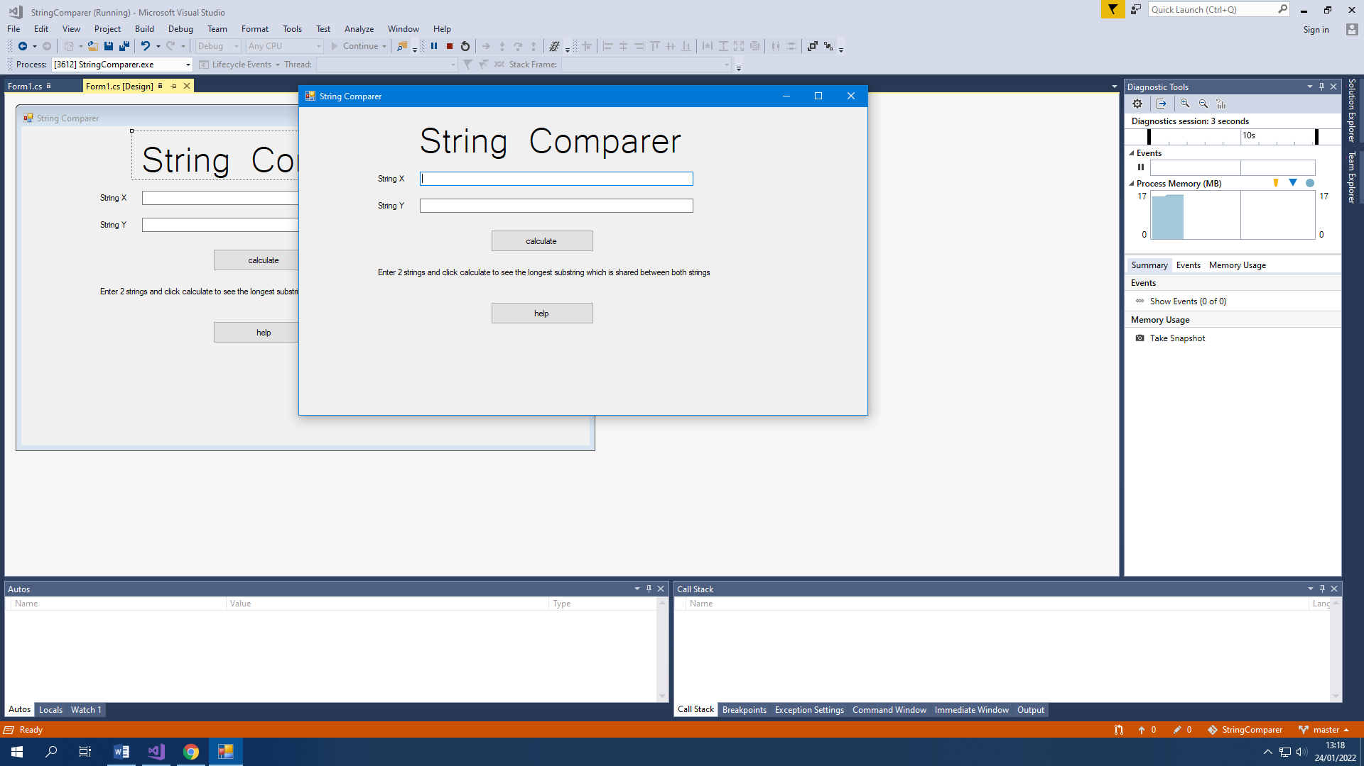

Screen shot 2.1

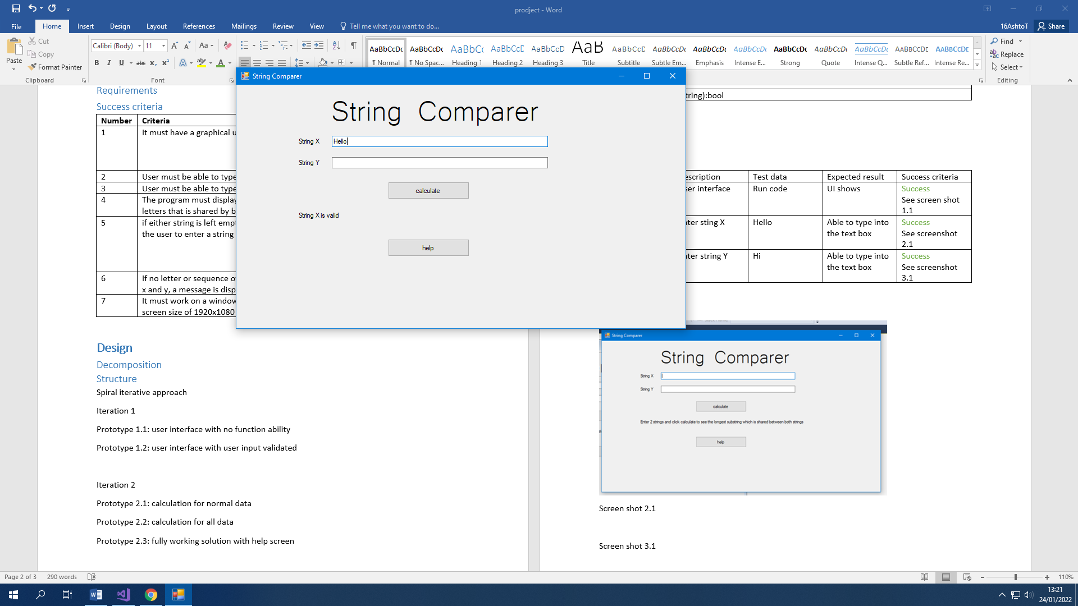

Screen shot 3.1

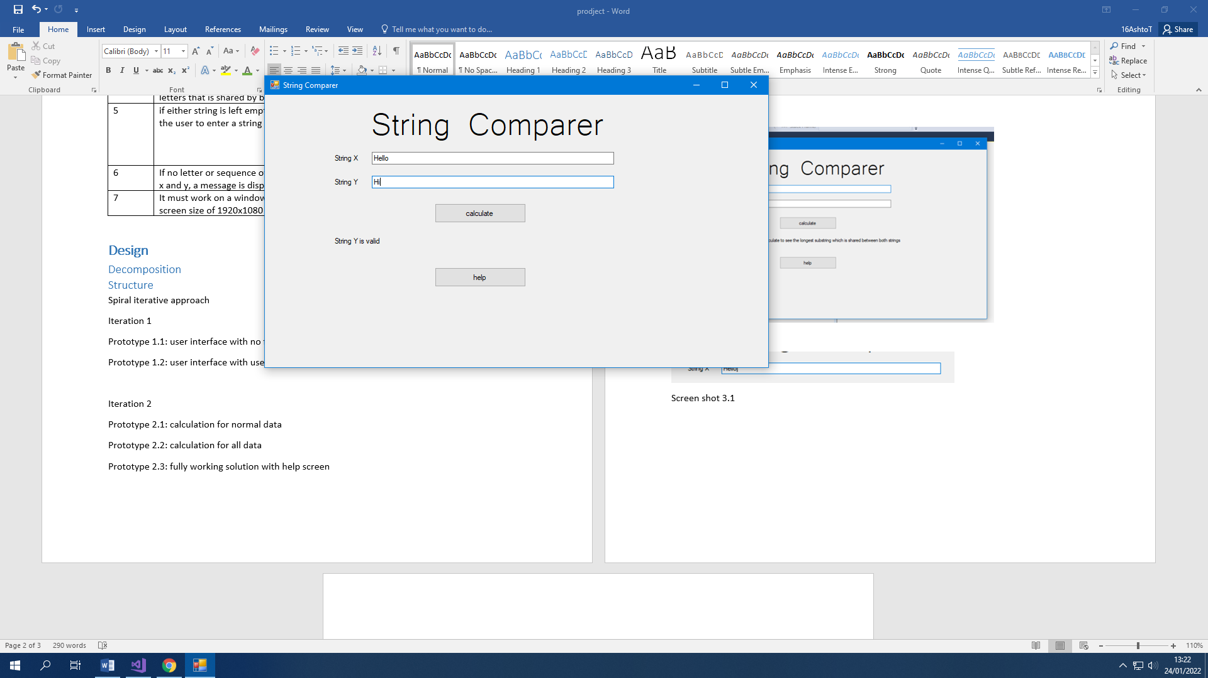

## Post development testing

# **Implementation**

# **Evaluation**